

ORIGIN 2026 RESEARCH SPRINT
CELESTE – A Space Research Centre
GNITS

1. Team Details
Team ID | Team 4
Team Members | Kaustubha Kodandapani, Anwitha Koneru, Chennuru Neelotpala, Gongalla Sloka Reddy
Roll Numbers | 24251A0449, 24251A0499, 24251A04A4, 24251A04A9
Paper Title | Navigating the Future of Space Exploration: An Overview of Reusable Launch Vehicles
Authors / Source | Naiyar H. Shaman, Robert O. Walton

2. Understanding the Paper: Context, Overview & Motivation

This study provides a structured overview of Reusable Launch Vehicles (RLVs), integrating technological, economic, and environmental perspectives based on a narrative review of 23 studies published between (2016 and 2024). This research was conducted as part of the Embry-Riddle Aeronautical University undergraduate research program, supporting undergraduate student research.
This is strictly an overview of how technological, economic, and sustainability findings interact, and to identify areas, particularly in economics and environmental governance, which are comparatively sparse.
The development of RLV’s and the corresponding literature explaining their advancement in any of the three domains: technological development, economic feasibility, environmental sustainability, has been highlighted.

3. Objectives / Purpose of the Paper

As a part of this study, Reusable Rocketry is examined through a qualitative survey of literature on reusable launch vehicles, with attention to technological advances and to the environmental, and regulatory conditions that shape their development.
Space Missions are undoubtedly very expensive and the use of traditional, single-use Expendable Launch Vehicles (ELVs) is not sustainable. In contrast, Reusable Launch Vehicles (RLVs) offer a cost-efficient way to access space, leading to increased launch frequency and helping mitigate the environmental impact of launches.
The aim of this review is to analyze recent research (2016-2024) and classify the findings of the studies into three dimensions that were identified: Technological Development, Economic Feasibility, Environmental Sustainability.
The discussion starts by analyzing the historical development of reusable rockets and their economic advantages while parallelly talking about their environmental impacts, regulatory regimes and government policies. It discusses about the significant lowering of launch costs which helped in reshaping the space market. It analyzes the shift of organizations like SpaceX and Blue Origin from government-led to commercially driven access to space.
It concludes by addressing emerging technologies, and the constraints that still remain as barriers, hindering the adoption of reusable rocketry.

4. Background & Key Concepts

- Reusable Launch Vehicles (RLVs)
- Propulsion Systems: The means by which thrust is generated to change the velocity of a vehicle.
- Expendable Launch Vehicles (ELVs)
- Space-as-a-Service: A system that enables consumers to make use of space capabilities with a monthly/yearly subscription fee that is much cheaper and more practical than building and maintaining personal launch vehicles.
- Technological Development
- Economic Feasibility
- Environmental Sustainability
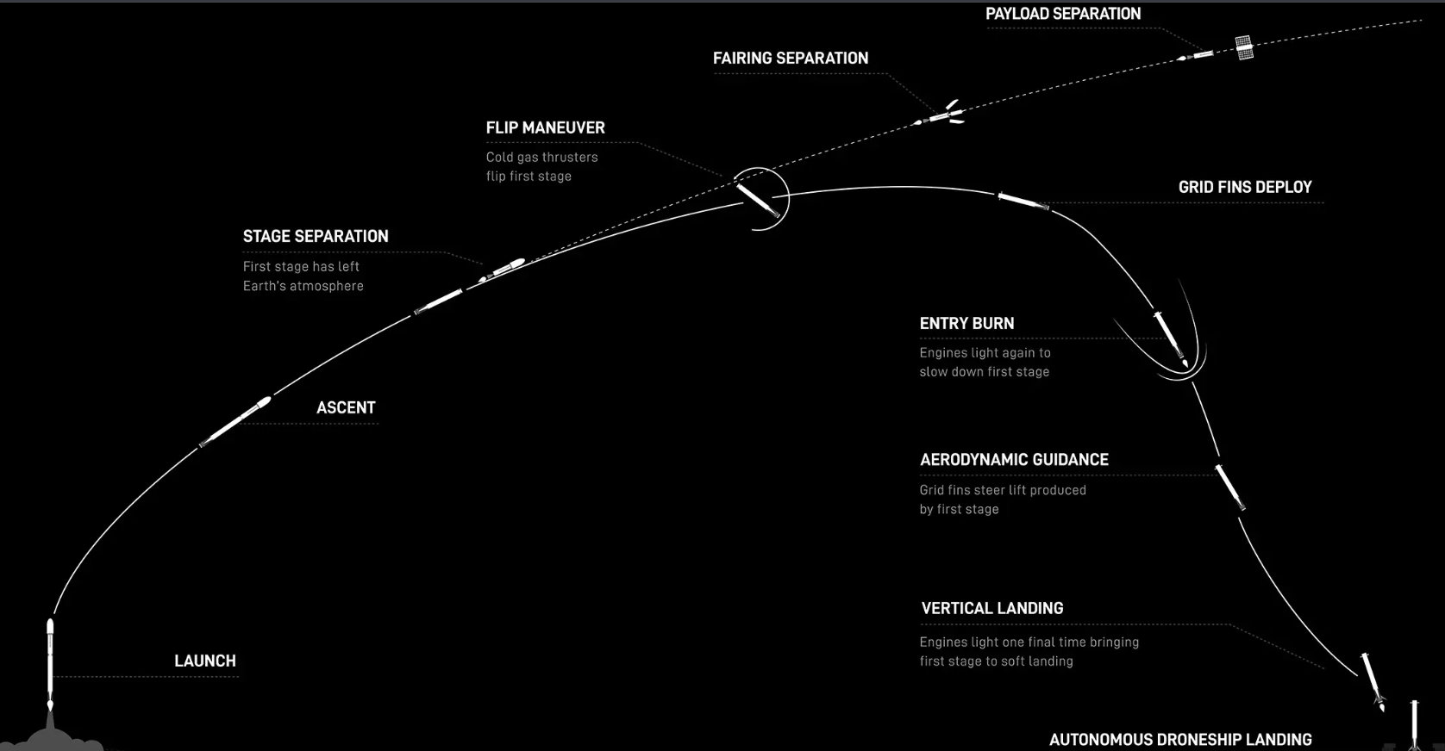

5. Methodology

This study uses a narrative literature review approach. Literature for this review was selected according to four criteria:
- First, studies which analysed reusable rocketry focusing on at least one of the following dimensions: technological developments, economic or commercial implications, environmental impacts, or policy and regulatory frameworks related to reusable launch vehicles (RLVs).
- Second, only work published between 2016 and 2024 was included, which resulted in a total of 23 sources.
- Third, priority was given to peer-reviewed material, including journal articles, conference papers, and academic theses.
- Finally, preference was given to sources accessible through academic databases and institutional subscriptions.

The 23 studies that met these criteria were then grouped into three analytical clusters: technological development, economic feasibility, and environmental sustainability

Studies focusing on propulsion and engine design, guidance and landing systems, thermal protection, and refurbishment practices were included in the category of technology.
Work examining launch costs, business models, and commercialization or privatization of the space sector was coded as economics.
Studies focusing on emissions, orbital debris, and environmental issues were coded as sustainability.

The examples discussed in the review include both suborbital and orbital systems.

7. Results & Observations

The papers identified three main clusters: Technological Development, Economic Feasibility, and Environmental Sustainability.
- Technological Development:

- Approximately half of the literature surveyed (12 of 23 papers), (52.2 percent) focused on the technological advances of RLVs.
- Several studies analysed propulsion and engine design, analysed guidance and landing systems, thermal protection, and maintenance practices of RLVs. These studies indicated progress in durability and turnaround time but highlighted the significant barrier of cost-effective reflight of spacecraft.
- Rocket engines are key to reusability, as they must withstand the stress of multiple launches and re-entries.
- Examples include SpaceX’s ninth Starship test flight, one of whose Raptor engines was on its third flight before the vehicle’s failure.
- Propulsion system improvements include staged combustion engines, throttle capability, and engines that burn cleaner fuels like liquid methane, making RLVs more reliable.
- Carbon–Carbon composites and Ultra High-Temperature Ceramics have significantly improved the ability of reusable rockets to withstand heat, enabling rapid return to service, extending the lifespans of RLVs.
- Maintenance, Repair and Overhaul (MRO) processes have been studied and it explains about the speed with which a launch vehicle is prepared for a re-launch. To reduce turnaround time, a modular design for parts is employed. If a part is found to be worn or damaged, it can be quickly replaced.
- Efficient MRO operations are critical to the long-term viability of reusable rockets.
- The development of advanced Guidance, Navigation, and Control (GNC) systems has enabled the precise landing of reusable rockets. Real-time data and autonomous decision-making is used to help systems adjust a vehicle’s trajectory during its landing.
- A growing use of machine learning and artificial intelligence in areas such as real-time guidance, fault detection, and predictive maintenance by analysing sensor data to detect early signs of component degradation is also observed.

- Economic Feasibility:

- The next theme identified was economic and commercial issues, with six papers (26.1 percent).
- This cluster too, along the lines of the first cluster, had a common theme that was the requirement for substantial upfront investment to achieve profitability in the RLV market.
- Cost-effective RLVs are presented as an economic requirement for future launch services.
- The studies also describe how business models are shifting from launching rockets to providing clients with flexible and scalable services.
- The lift market is moving towards a Space as a Service model and this evolution is expected to shape the future development of the space economy.
- The literature reviews state that the commercial and tourism sectors are booming, creating jobs and encouraging innovation in the space industry but, at the same time, this increase in demand is attracting more firms to enter the launch business and creating competition.
- Alongside, the financial barrier to market entry still remains extremely high.

- Environmental Sustainability:

- The third cluster, comprising five papers (21.7 percent), addressed environmental and sustainability concerns.
- This group observed that while the reuse of spacecraft can reduce manufacturing waste, the increased launch frequency that RLVs can offer may offset these benefits, highlighting the need for international governance of the space launch market.
- Emissions from rocket launches release large amounts of carbon dioxide and other pollutants into the upper atmosphere, where they stay longer and do more damage than surface level emissions.
- As launch rates increase and satellite constellations expand, the risk of orbital collisions increases. The literature marks that policies regarding end-of-life disposal and active debris removal as critical. Some studies highlight approaches such as moving satellites to a designated graveyard orbit to reduce congestion.
- The reviewed studies emphasized that environmental and regulatory issues do not stop at national borders.
- International frameworks, such as the UN’s guidelines for the long-term sustainability of outer space, are examples of efforts to manage these risks and can help shape future international policies.

8. Applications & Significance

Reusable Launch Vehicles (RLVs) have direct relevance to the future of space transportation as they enable frequent launches, reduced per-launch costs, and repeated use of expensive propulsion and vehicle systems.
Their applications include commercial satellite deployment, rideshare missions, space tourism, and future high cadence space operations.
The paper also highlights the importance of predictive maintenance, sensor-based health monitoring, autonomous guidance, and advanced thermal protection, which can improve vehicle reliability and reduce turnaround time between missions.
RLVs support the development of commercial Space-as-a-Service models, allowing multiple customers and payloads to benefit from the launch opportunities.
For the future, although the paper emphasizes that economic viability, launch-related emissions, orbital congestion, and regulatory frameworks remain important research and operational challenges.

9. Limitations / Challenges / Research Gaps

An evident limitation is the study being based off of researches from 2016-2024, which highlights the advancements but completely ignores the foundational researches that primarily contributed to arrive at the stage that the technology is presently in.
It is observed that just over half of the surveyed articles (12 of 23) focused on technological advances, while only six addressed economic and commercial aspects, and five addressed environmental and sustainability concerns.
This imbalance suggests that technology development has received more attention than the economic, regulatory, and environmental dimensions of RLVs, which are also very important factors to consider, with the adoption and the upcoming long-term usage of RLVs in practice.
Therefore, the results indicate that while the technical foundations of reusable rocketry are being actively advanced and analysed, further research is needed on the economic conditions required to sustain RLV operations and on the environmental and policy mechanisms.

10. Future Scope / Future Directions

As the paper is a study strictly from 2016 to 2024, analysis of a few papers from 2024-2026 could help give further insights on how or if any of the issues mentioned by this paper have been solved yet.
This paper is a good source of information about basic issues that have been prevalent, which can be kept in mind for future endeavors.
India has only started played its part in the RLV launch, as test runs have taken place to get familiar with the technology.
An example of an Indian RLV to be launched soon, i.e., PUSHPAK, scheduled for late 2026-27 has undergone the following Landing Experiments (LEX):
- RLV-LEX-01 (April 2023): Demonstrated the basic autonomous runway landing capabilities of the winged vehicle.
- RLV-LEX-02 (March 2024): Tested the vehicle’s ability to correct itself autonomously from difficult, simulated high-speed conditions.
- RLV-LEX-03 (June 2024): The final landing test, which proved Pushpak could handle severe crosswinds and high-velocity landings.

According to the future scope of the paper, the authors recommend future researchers to take up a single topic, like Propulsion system advancement, GNC, etc. and perform a detailed, quantitative analysis to get a clear idea about how a particular field is advancing and any improvements to make it better.

11. Conclusion: Team’s Understanding & Interpretation
This broad overview of reusable launch vehicles has focused on the technological development, economic feasibility, and environmental sustainability regarding the future of space exploration.
In the technological dimension, the reviewed studies show a substantial progress in propulsion systems, thermal protection, materials, MRO processes, and guidance, navigation, and control, demonstrating that reusability is now a proven concept in operational launch systems.
At the same time, we can also conclude that cost-effective reflight remains challenging, as vehicles must combine durability, rapid refurbishment, and high launch cadence to realize the full benefits of reusability.
From an economic perspective, we can see that RLVs can reduce per-launch costs by spreading fixed costs across multiple flights and enabling new business models such as Space as a Service.
Lower launch costs are opening access to space for a wider range of commercial, governmental, and emerging actors, even as high upfront capital investment and significant barriers to entry persist.
As for sustainability, the studies indicate that reusability can reduce manufacturing waste and material use, but rising launch rates may hinder these gains by increasing inflight emissions and damaging orbital environment.
Emissions, orbital debris, and the risk of congestion in low Earth orbit highlight the need for a strong environmental regulation and effective end-of-life practices, developed within an international rather than purely national policy framework.
So, to conclude, we see that Reusable launch vehicles will help in increasing launch rates and reducing costs to support a future space economy, but realizing this potential will depend on continued advances in propulsion, materials, thermal protection, maintenance, etc.

12. References

- Naiyar H. Shaman, Robert O. Walton, “Navigating the Future of Space Exploration: An Overview of Reusable Launch Vehicles”, Embry-Riddle Aeronautical University undergraduate research program

- P. Baiocco, “Overview of reusable space systems with a look to technology aspects,” Acta Astronautica, vol. 189, p. 10–25, Dec. 2021.

- https://www.isro.gov.in/RLV_Landing_Experiment.html

